Appendix 1 – Colour Blindness

Below is an example of the web pages colour scheme Paletton.com (2019).
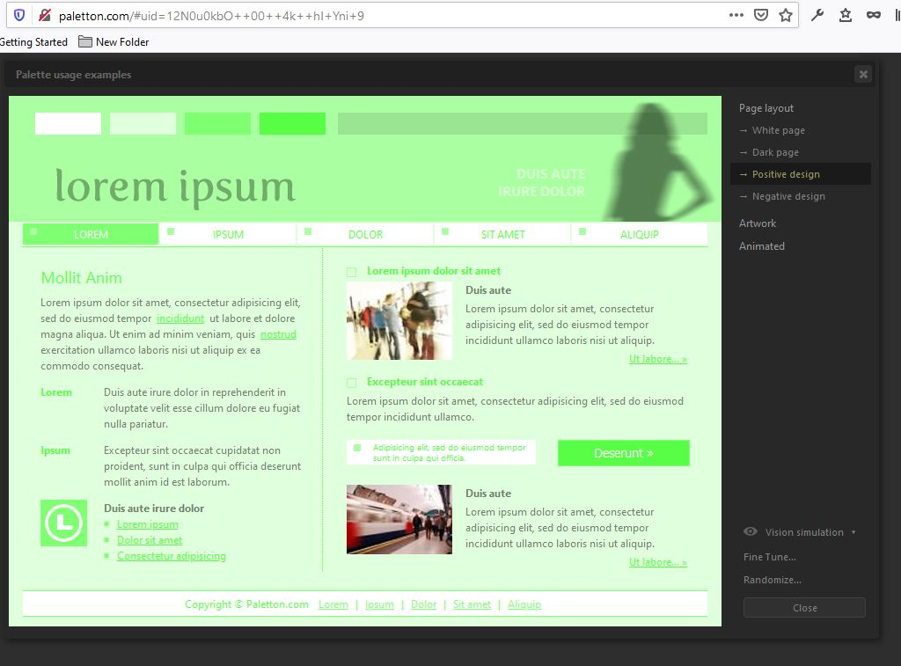

Below is an example of the web pages colour scheme Paletton.com (2019) as viewed by an individual who has the Deuternomaly form of colour blindness.
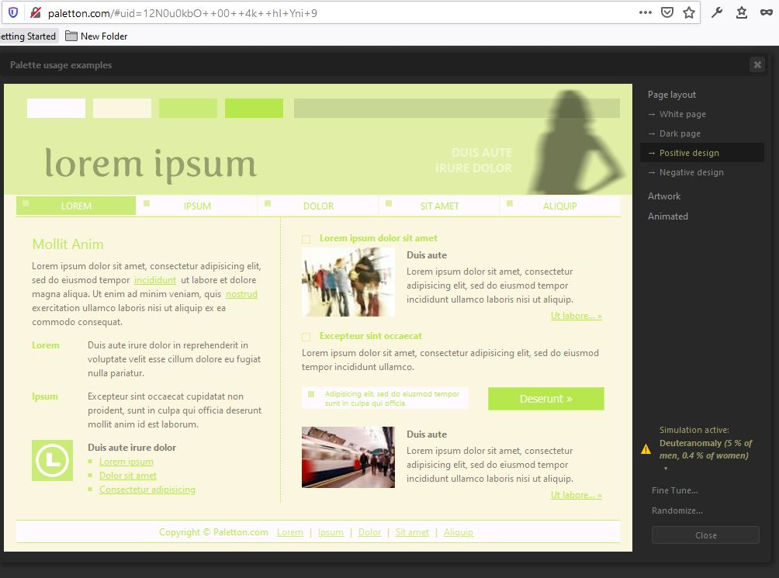

Below is an example of the web pages colour scheme Paletton.com (2019) as viewed by an individual who has the Protanopia form of colour blindness.
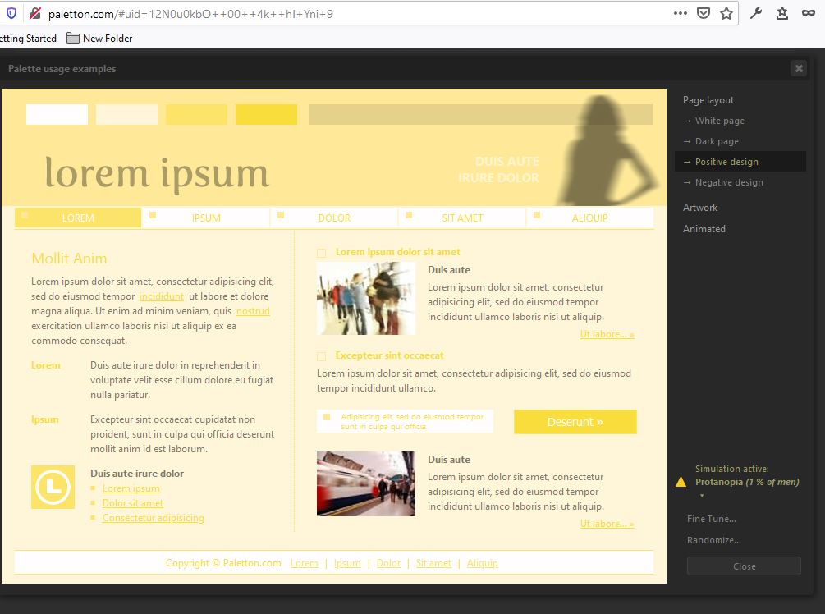

Below is an example of the web pages colour scheme Paletton.com (2019) as viewed by an individual who has the Dyschromatopsia form of colour blindness.
